Camilla Heath
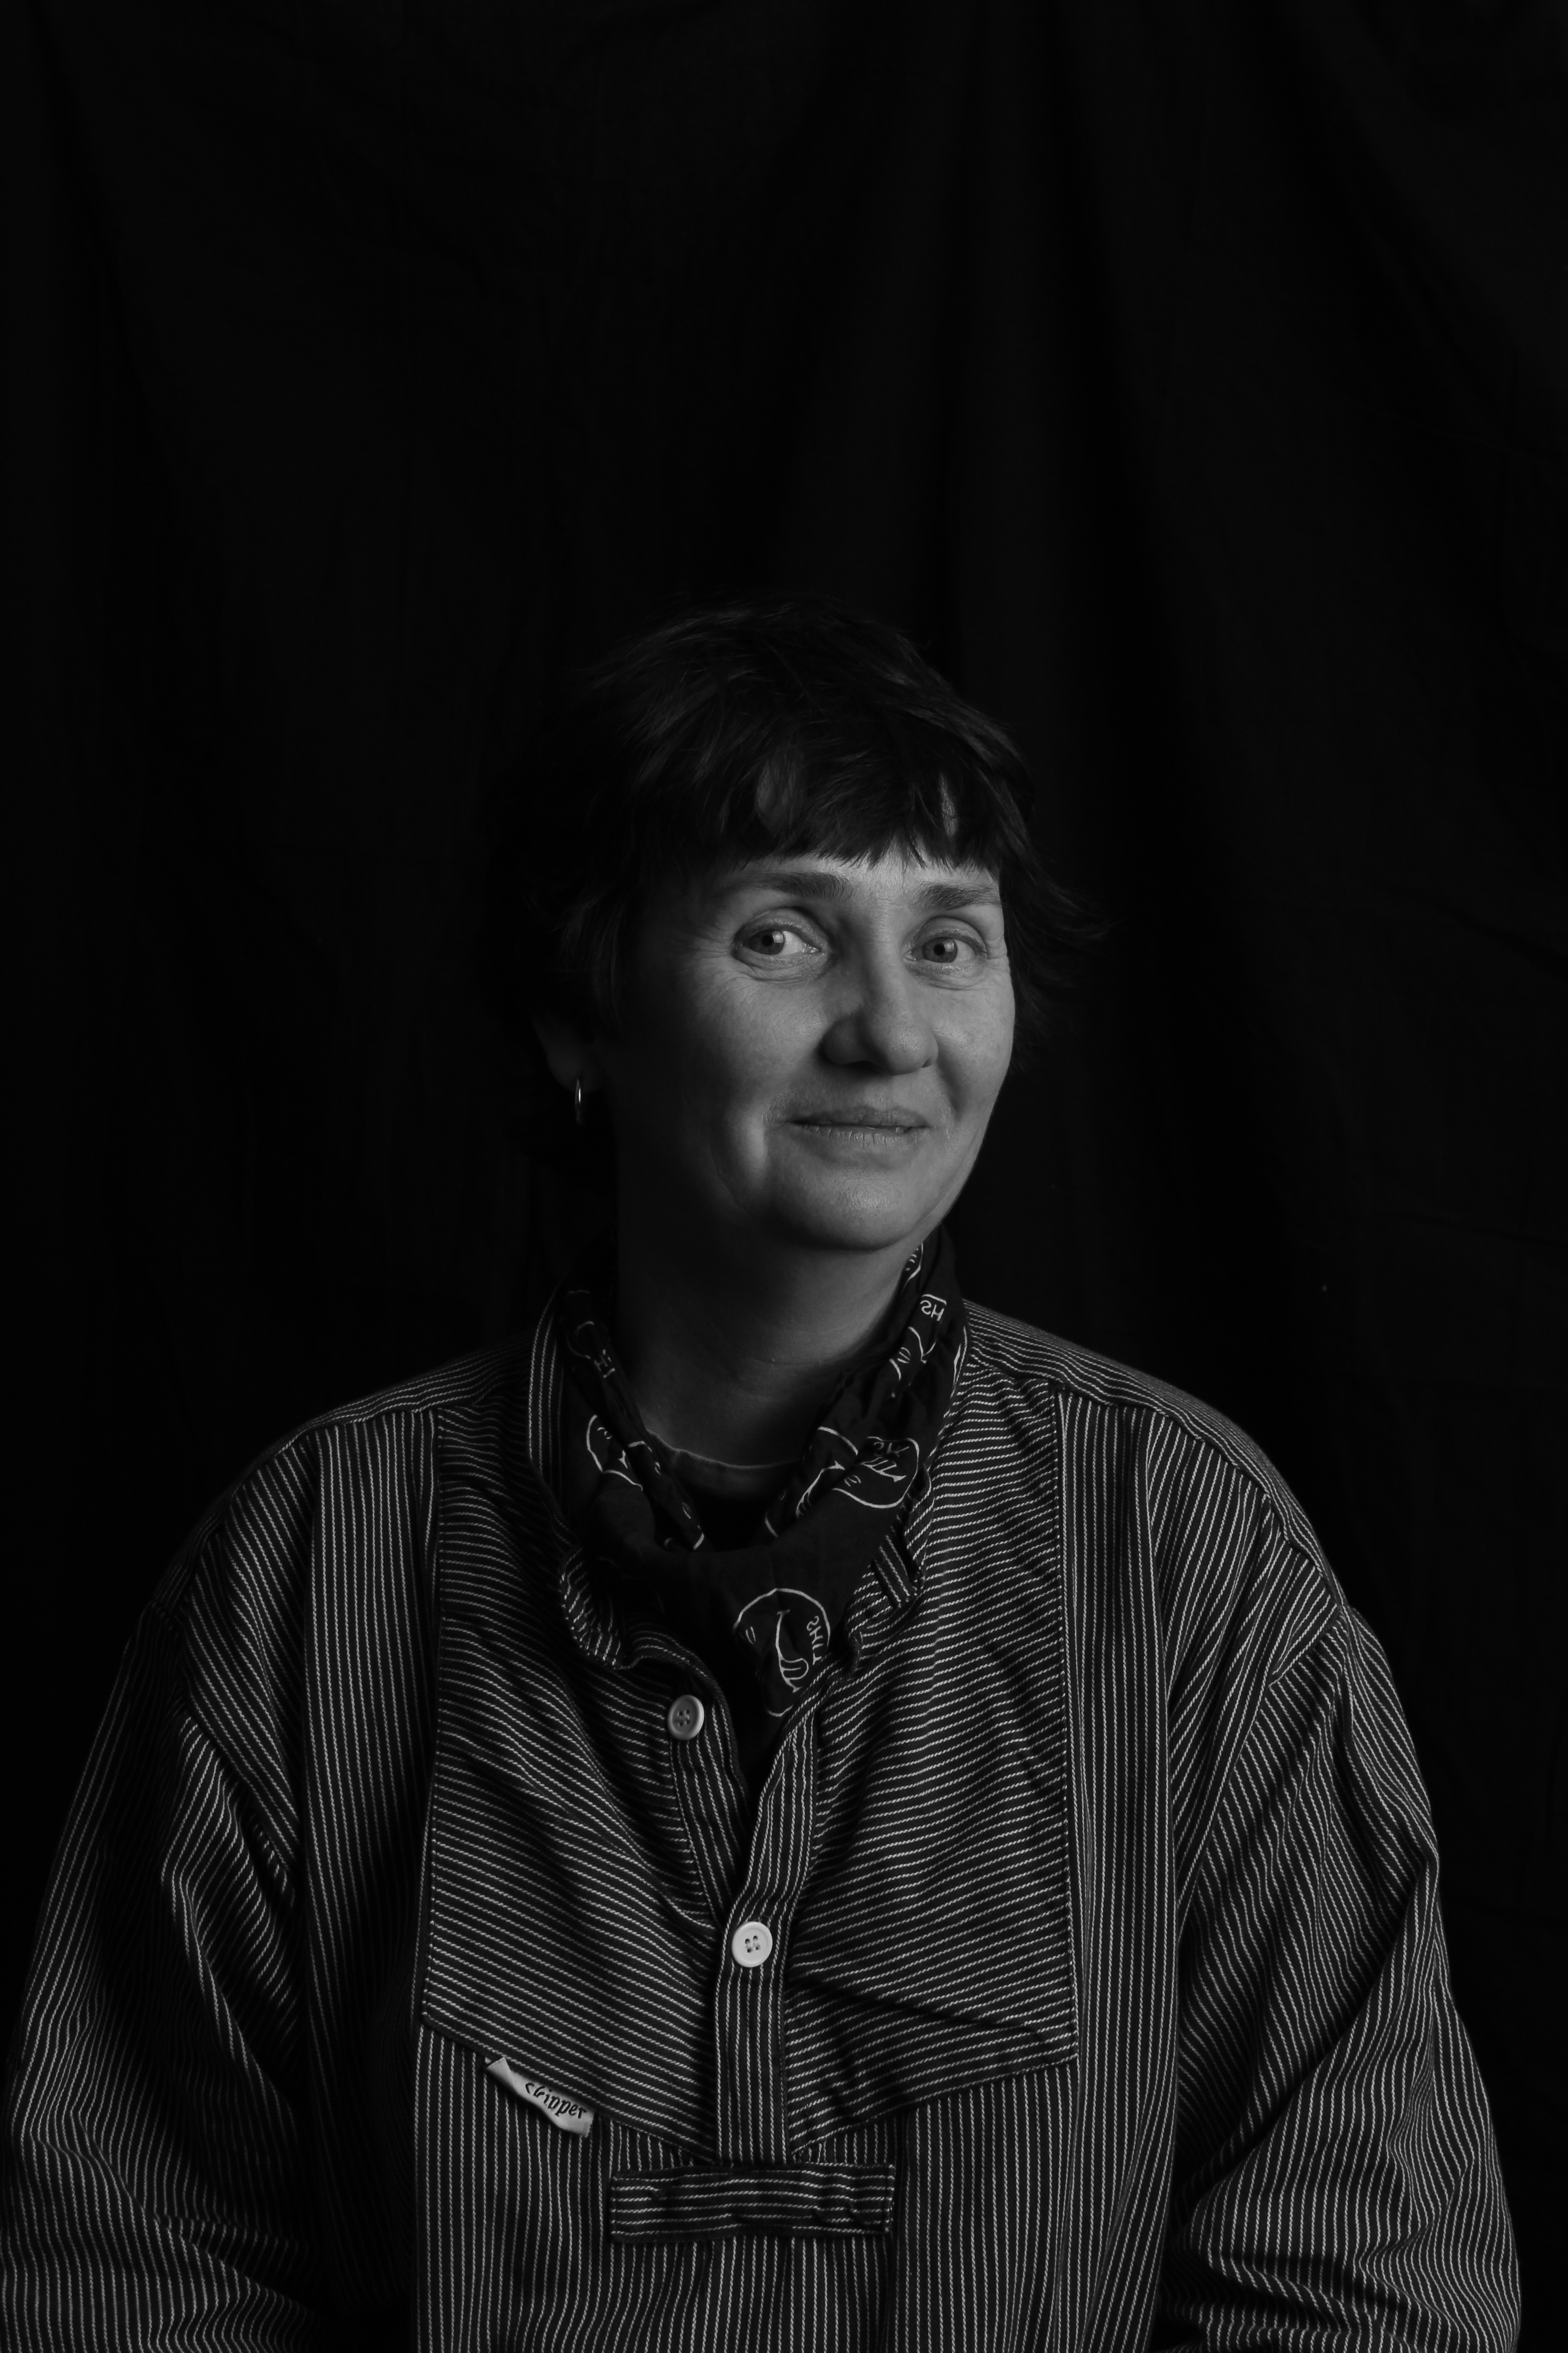

Phone: +31 614207181

camillaheath@gmail.com

http://camillateach.wespdesign.nl

Education | MEd University of Applied Sciences HvA, Amsterdam  Research in film and vocabulary acquisition  B.Ed. University of Applied Sciences HvA,  English teaching degree with Honours  Post Vrije Academie, The Hague.  BA Central/St Martins, London  Film and Theatre  F Middlesex University
Honors and Awards | European Education Summit, Brussels 2021, 2019  PDW e-twinning Conference Munich 2017  Grant from European Community – ICT/Language Course, Malta 2012  Winner of Cactus to Conference Scholarship – IATEFL 2011  DMO Award for Travel 2010
Courses | - HU diploma assessor Masters and Bachelor 2020  - HvA Diploma assessor for BP2 and BP3 2014  - Montessori teaching course with Honours 2009
Teaching & Academic administration | IVKO, Amsterdam  Teacher, (English CITO, Cambridge, Theatre Studies, Theatre Design)  Mentor,  Dean, 2008 – ongoing.  - Dean of havo department.  - Teacher/trainer for teachers at HBO and MBO level  Huizermaat, Huizen  Tutor and mentor, 2014 - 2015 – mavo, havo, vwo, vwo-P and vwo-T.  HvA, University of Applied Sciences, Amsterdam  Tutor and Mentor, 2010 through 2014  - Taught Academic English, Drama in the Class - undergraduate courses averaging 120 students per semester, covering the following topics: English for Academic purposes, English in Nutrition.  - Developed archive for accreditation  - Revised the syllabus to meet accreditation standards  - Mentored second through seventh year students and portfolio work.  NFTA, Amsterdam  Support staff 2003 - 2012
Publications | IATEFL Conference Selections 2018  Small contributions to Voices (IATEFL Magazine) and Cactus Language website 2011, 2012.
Professional Training | Shared Leadership – HvA/Gemeente Amsterdam 2019  Didactic Coaching 2018 - 20  In Design - 2018
Professional Service | Lecture ‘The Free Cypher’ IATEFL 2019  Lecture ‘Learning to play’ Expolingua, Berlin, 2018  Book Content Developer, Noordhoff Publishers 2016 ongoing:  Stepping Stones 3 & 4 bk, 1 havo 7th edition 4 vwo & 5/6 vwo 6th editions  Lecture ‘Learning to Speak’ IATEFL, 2018.  Lecture ‘Choosing to Learn’ at The Language Show, UK, 2016.  Lecture ‘Teaching Teens with subtitles’ at The Language Show, UK, 2015  Head of English Department, IVKO 2015 - 22  Head of International Department, IVKO  2009 - 2012

References:
Kim Wannet – K.Wannet@msa.nl (Directeur IVKO)
Roos Hibma – R.Hibma@msa.nl (Adjunct IVKO)

